**Principles of management**

So, First of all What is Management? Management is a phenomenon that belongs to every person. Management is managing things in a structured way. All persons need to manage their Personal and Professional life which includes setting a goal, making a plan, activity control to achieve a thing in your life whatever you want. Management included Time Management, Work Management, Goal Management etc.

**Operation of Management:-**

* Planning
* Organizing
* Leading
* Controlling

These are the keywords of Management……

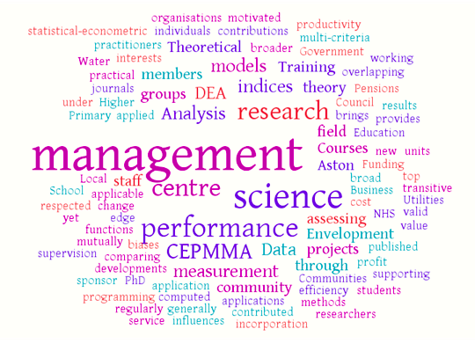

**Is Management a Science or an Art?**

Management combines features of both science as well as art. It is a science because it has an organized body of knowledge which contains certain universal truths. Management is achieved after applying the thinking power of the human brain so we can call it an art. It’s a combination of both.

**Fayol identified fourteen principles of management and those principles of management are as follows:**

* Specialization of labor
* Authority
* Unity of command
* Discipline
* Subordination of individual interest to common good
* Unity of direction
* Initiative
* Esprit de corps
* Personal tenure
* Equity
* Order
* Scale of chain
* Centralization
* Remuneration

**Benefits of Management:-**

* Increase Productivity, Creativity, Performance.
* Time Utilization in a proper way
* Helpful to achieve a goal with happy face
* Providing Vitality to organization and in personal life too
* Helpful to manage the coordination with people